**Conceptual Data Modeling**

**Were Vincent**

### ****Introduction****

This assignment report presents a conceptual data model designed for a local charity organization to address challenges in managing their auction and fundraising activities. The model aims to improve operational efficiency, enhance accountability, and maximize fundraising revenue by streamlining donor and bidder information management.

### ****Identified Entities and Attributes****

#### *****Extracted Entities*****

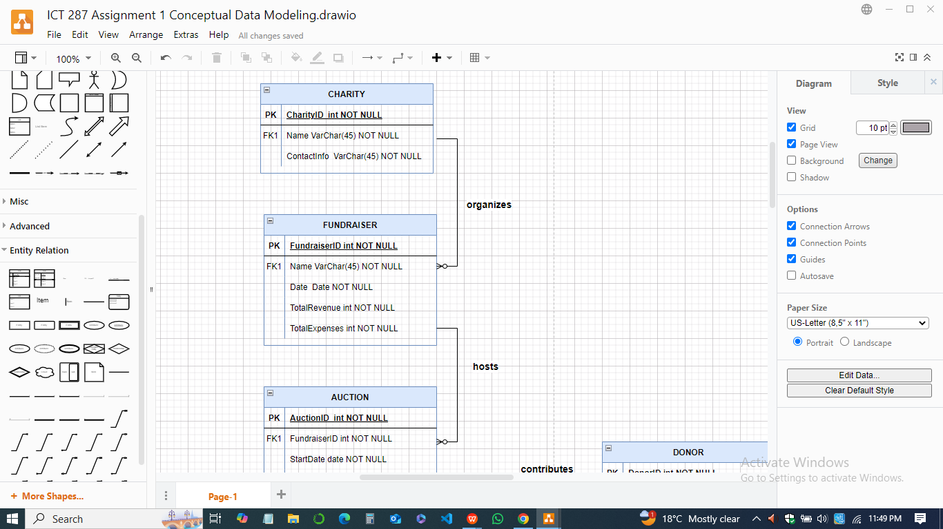

1. **Charity**

* ***Attributes -*** CharityID, Name, ContactInfo

1. **Fundraiser**

* ***Attributes -*** FundraiserID, Name, Date, TotalRevenue, TotalExpenses

1. **Donor**

* ***Attributes -*** DonorID, Name, Address, ContactInfo

1. **Donation Item**

* ***Attributes -*** ItemID, Name, Description, EstimatedValue, AuctionPrice, StorageLocation

1. **Bidder**

* Attributes: BidderID, Name, ContactInfo, RegistrationDate

1. **Auction**

* ***Attributes -*** AuctionID, FundraiserID, StartDate, EndDate

1. **Bid**

* ***Attributes -***  BidID, ItemID, BidderID, BidAmount, Timestamp

1. **Payment**

* ***Attributes -*** PaymentID, BidID, AmountPaid, PaymentDate

#### *****Candidate Entities*****

1. **Event Staff**

* ***Attributes -*** StaffID, Name, Role, ContactInfo

1. **Feedback**

* ***Attributes -*** FeedbackID, EntityType (Donor/Bidder), FeedbackText, SubmissionDate

#### *****Relationships*****

1. **Charity organizes Fundraisers**

* One charity organizes multiple fundraisers; a fundraiser belongs to one charity.

1. **Fundraiser hosts Auctions**

* Each fundraiser can host multiple auctions; each auction belongs to one fundraiser.

1. **Donor contributes Donation Items**

* A donor can contribute multiple items; each item is provided by one donor.

1. **Donation Items are auctioned in Auctions**

* Each item is part of one auction; each auction features multiple items.

1. **Bidder participates in Auctions**

* A bidder can participate in multiple auctions; an auction can have multiple bidders.

1. **Bidder places Bids on Donation Items**

* A bidder can place multiple bids; each bid is for one item.

1. **Bid results in Payments**

* Each bid can result in one payment; each payment is linked to one bid.

### ****E-R Diagram****

Below is the conceptual E-R diagram illustrating entities, attributes, and relationships:

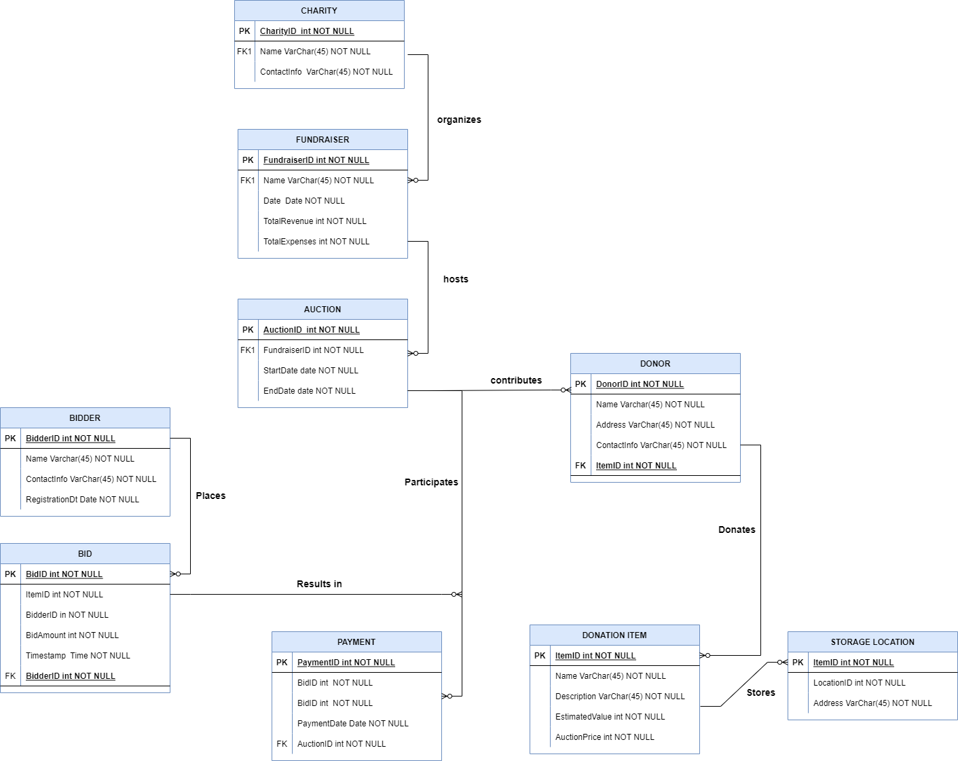

### ****Assumptions and Justifications****

1. ***Feedback Entity -*** Included to capture donor and bidder feedback for improving future fundraising events.
2. ***Event Staff Entity -*** Added to manage operational roles and responsibilities.
3. ***Bidder Participation Tracking -*** To ensure accountability and extend future invitations.

### ****Conclusion****

The proposed data model ensures efficient management of charity auctions and donor-bidder relationships while enhancing accountability and reconciliation processes. It addresses the challenges identified in the narrative and provides a robust foundation for implementing a database system.